When the administrator logs in, they are directed to the Admin Dashboard. The dashboard provides an overview of total users, active prescriptions, pending approvals, and system activity. It also displays recently registered users, system health and alerts, and quick actions for adding users, viewing system logs, generating audit reports, and managing roles.
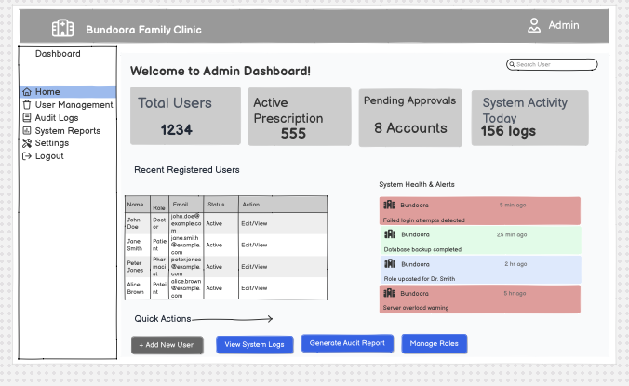

When the administrator selects User Management, they are directed to the User Management page. The administrator can search users by name or email, filter users according to role and account status, create new users, and perform actions such as edit, delete, view, or approve user accounts.
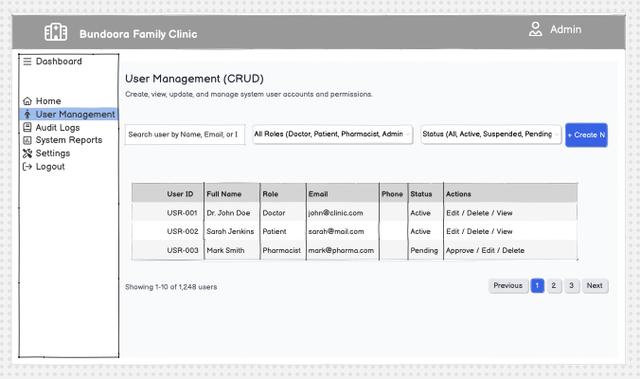

When the administrator selects Audit Logs, they can review system activities, login histories, security events, and data changes. The administrator can filter the records by date, action, and activity level. Each log displays the timestamp, user, role, action performed, IP address, target resource, and status.
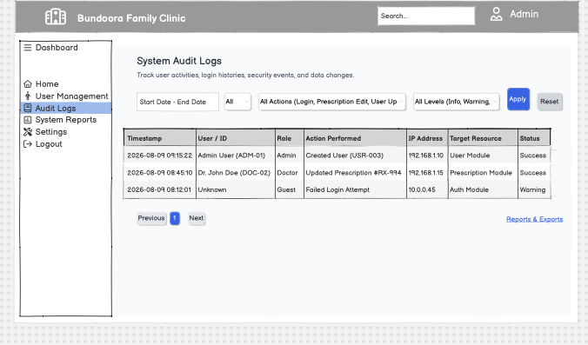

When the administrator selects System Reports, they are directed to the Reports & Data Export page. The administrator can select a report type, choose a start and end date, select an export format such as PDF, Excel, or CSV, and generate and download the required report. Recently generated reports are also displayed on this page.
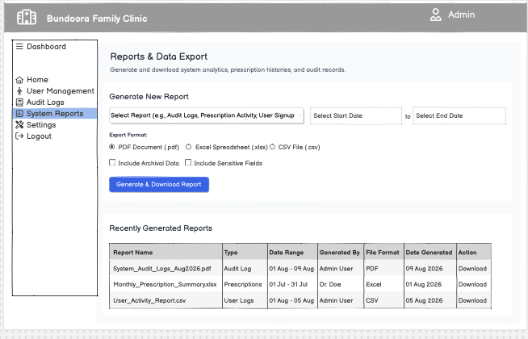

When the administrator selects Settings, they are directed to the Application Settings page. The administrator can configure general settings such as application name, default language, timezone, and date format. They can also manage notification settings and security settings including two-factor authentication, session timeout, and password changes.
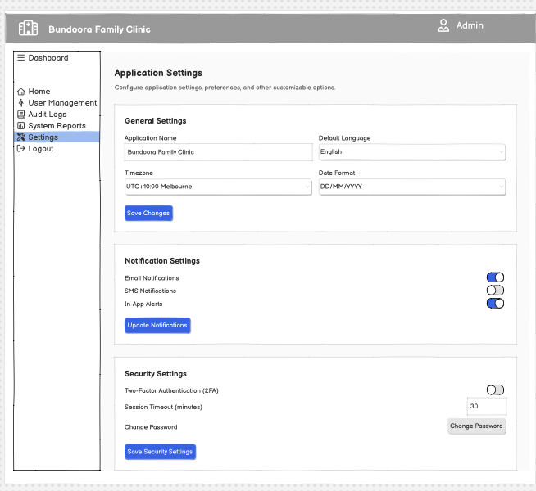

When the administrator selects Logout, the system ends the current session and displays a logout confirmation message. The administrator can then return to the login page or go to the home page.
